Fox Trotters on the Forefront
Born to Jump: Shaker’s Jamaican Pride, J.A.K.S., and Ms. T.
By Josephine Cozean Styron
“When I am competing over fences, I need a horse that is willing to explode like a rocket, spin on a dime, and stop from a gallop immediately.” Alexandra (Ali) Cooper, jump rider/trainer.
Show jumping is essentially a speed event that includes jumps, making it one of the most athletic of equine sports. Kirsten Klindworth’s Missouri Fox Trotters are excelling at it. But, it took a determined owner, a once-doubtful rider, and three horses with the will to win to prove that Missouri Fox Trotters have what it takes to successfully compete in the world of United States Equestrian Federation (USEF) show jumping.
It began when Klindworth, of Liberty Hill, Texas, asked her friend and trainer Ali Cooper if she thought Klindworth’s Fox Trotters could be trained to jump. Cooper, who was competing warmblood and thoroughbred horses in the hunter/jumper circuit for other clients, thought for a while then said, “Sure, we can try, but I don’t think they will be that good at it.” After trying each of them, “I was pleasantly surprised. None of them refused, all were so willing, and they quickly were developing beautiful form. Before we knew it, we were jumping respectable size fences,” said Cooper.
Determined to find out how high the horses could jump, the women slowly raised the fences. “They each jumped around four feet, and one of them jumped 4’3”!” said Cooper. “That’s when I knew that these guys could be great in the jumper circuits. They were fast, agile, willing, and could jump!”
Within six months, the horses were clearing 3’6” oxers, which are two verticals together. “This is the drop out point for many horses that compete,” said Klindworth. When Shaker’s Jamaican Pride (Leo) and J.A.K.S. sailed over a 4’3” oxer, “Ali was beyond words,” said Klindworth. “She never thought these smaller gaited horses would ever be able to accomplish such a feat.”
Cooper said, “If they can go this high, we can compete with the real jumpers at the Class A shows.” Cooper knew what they were in for, but she admired Klindworth’s “faith in these horses and her willingness to go against the odds and show at places where we would not be welcomed and likely be made fun of,” she said.
They started small, attending a 4-H show where they placed but didn’t win. “It was our first experience with show prejudice against the gait,” said Klindworth. “Some of the judges thought they were lame because of their unusual, smooth gaits and judged us accordingly. We had our first inkling of what was to follow, but we knew we were on to something–if we could just get a fair shake,” she said.
But the Fox Trotters’ calm disposition, jumping ability, and way of going were gaining them some fans. “In stark contrast to the larger warmbloods and thoroughbreds, our Fox Trotters appeared to float around the arena, their feet barely touching the ground. Several people asked if they were for sale,” said Klindworth.
At the 2009 Gaited Gala in Athens, Tx., they won Hunter Hack, Hunter Over Fences, and Ms. T. won Overall Adult Versatility Champion after doing well in barrels, poles, trail, and jumping classes. But, Cooper wanted to take on “the real jumpers at a Class A Jumping Show.”
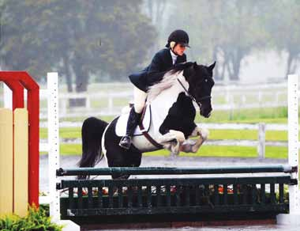They got their chance at the Blue Ribbon Summer Festival II in Waco, Tx. Sponsored by USEF and the Texas Hunter Jumper Association, it was their first Class A show, and their first experience being in a massive indoor coliseum. Loud buzzers went off before each round, and the jumps were different colors and shapes, causing even seasoned horses to refuse them. It was also the first time they would be judged solely on jumping ability and speed, competing against much larger horses that had, for hundreds of years, been bred specifically for this discipline. “We got some unusual looks, and a few people asked, ‘Can those horses jump?’ We were ready to find out,” said Klindworth.
The three Fox Trotters placed in almost every class they went in. “We were Grand Champion in the Power Jumping Class. Ms. T. won first, J.A.K.S. placed third and Leo won 6th out of 17 horses. Even more amazing was that Ms. T. was the first horse to show in the class, so every other rider knew her time and couldn’t beat her. J.A.K.S. then won 3rd at Speed Jumping,” said Klindworth. Pretty good for three 15-hand Fox Trotters who compete barefoot!
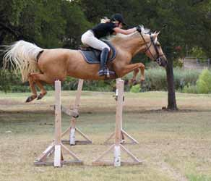The horses have gone on to successfully compete in other jumping shows. Leo was the World Champion in Jumping at the MFTHBA 2009 Fall Show and Celebration. After being laid off all winter, he went on to compete successfully at the 2010 St. Christopher show, a USEF Class AA show, and the four-year-old tobiano stallion was named Overall Hunter Over Fences Grand Champion at a show in Pennsylvania. According to Klindworth, in the just the last few months of showing, Leo has won eight division championships and 16 first places in open jumping shows.
So, when faced with the initial prejudice of the show jumping world, what kept them going? “The amazing ability and fantastic form the Fox Trotters have,” said Klindworth, “and their speed and agility at the turns. They are much faster than most of the other jumpers. It is beautiful to watch.”
Cooper added, “I look for responsiveness, desire, and trust. I need a horse that trusts me enough to take the big spot; fit through two jumps, even when the hole is really tight; or jump the jump that looks like a monster. I look for horses that enjoy pleasing me, enjoy showing, and want to win. They will give it their all. These are the traits that make the difference between good and great, and Kirsten’s horses showed me these traits time and time again.”
When Cooper competes at a show, she purposely gaits the horses around the arena first. She wants everyone to know: She’s riding a Missouri Fox Trotter.

